Normalization Lab

1) Your task in this exercise is to move the un-normalized table to 3NF. To do this, use the dependency diagram.
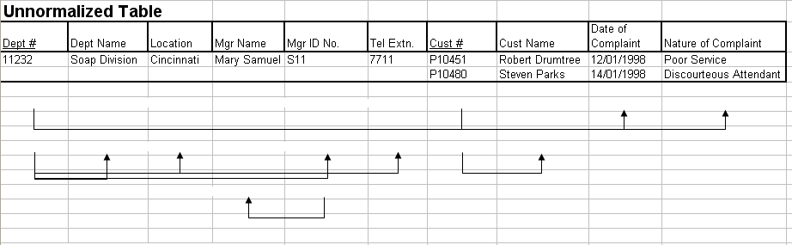

1 NF :- \\

1 ) Dept
(Dept# , Dept-Name , Location , Mgr-Name , Mgr-ID , Telephone)

2) Customer
(Dept # , Cust # , Cust-Name , Date of Complaint , Nature of Complaint )

2 NF :- \\

1 ) Dept
(Dept# , Dept-Name , Location , Mgr-Name , Mgr-ID , Telephone)

2) Customer Complaint
(Dept # , Cust # , Date of Complaint , Nature of Complaint )

3) Customer
(Cust # , Cust-Name )

3 NF :- \\

1 ) Dept
(Dept# , Dept-Name , Location , Mgr-ID , Telephone)

2 ) Managers
(Mngr-ID , Mngr-Name)

2) Customer Complaint
(Dept # , Cust # , Date of Complaint , Nature of Complaint )

3) Customer
(Cust # , Cust-Name )

2- Employee and Projects
The table below depicts the requirements for a business consultancy working on local and international projects.
Emp-No | Emp-Name | Dept | Dept Manager | Proj-id | Proj-Start-Date | Location | Weeks-on-Project
005 | Smith | Marketing | Jones | A  B  C | 12-1993  06-1994  09-1994 | Poole  Plymouth  Portsmouth | 11  15  6
007 | Bond | Accounts | Bloggs | B  D | 06-1994  06-1994 | Plymouth  Berlin | 3  9
009 | King | Info Systems | Hurne | C | 09-1994 | Portsmouth | 10
010 | Holt | Accounts | Bloggs | A  B  D | 12-1993  06-1994  06-1994 | Poole  Belfast Hamburg | 21  10  12
Emp.no is the primary key. Employees work on a number of projects concurrently. Weeks-on-project represents the number of weeks that an employee has spent on a particular. The employee number, emp-no, and the project identifier, project-id, are unique identifiers. The department manager, manager, is the name of the current manager, i.e., there can be only one manager per department. A project can take place in several locations (i.e Employees can work on a project from their location). You are required to show the first, second and third normal forms.
1 NF :- \\

1 ) Employee
(Emp-No , Emp-Name , Department , Dpt Mngr )

2) Projects
(Emp-No , Project-ID , Project-StartDate , Location , Weeks On Project )

2 NF :- \\

1 ) Employee
(Emp-No , Emp-Name , Department , Dpt Mngr )

2) Emp of Projects
(Emp-No , Project-ID , Location , Weeks On Project )

3) Project Start
(Project-ID , Project-StartDate)

3 NF :- \\

1 ) Employee
(Emp-No , Emp-Name , Department)

2) Manager
(Department , Dpt Mngr )

3) Emp of Projects
(Emp-No , Project-ID , Location , Weeks On Project )

4) Project Start
(Project-ID , Project-StartDate)
3- Normalization:

The following table represents the database of a system that stores data about all Car Companies in Egypt. Model ID is the identifier for each model with a specific color. Selling Price is the price of that model in the specified Company. Available Quantity is the quantity of the model in this Company. Dealer is the distributer (موزع) of the specified model regardless of the Company. Company ID is the current Primary Key of the table.
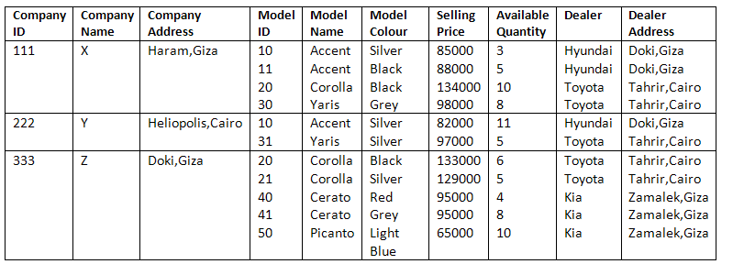
You are required to show the first, second and third normal forms.

1 NF :- \\

1 ) Company
(Company-ID, Company-Name , Address)

2) Company Models
(Company-ID, Model-ID , Model-Name , Color , Selling Price , Quantity , Dealer , Dealer Address)

2 NF :- \\

1 ) Company
(Company-ID , Company-Name , Address)

2) Company Models
(Company-ID, Model-ID , Selling Price , Quantity)

3) Models
(Model-ID , Model-Name , Color , Dealer , Dealer Address)

3 NF :- \\

1 ) Company
(Company-ID , Company-Name , Address)

2) Company Models
(Company-ID, Model-ID , Selling Price , Quantity )

3) Models
(Model-ID , Color , Model-Name , Dealer)

4) Dealer
(Dealer, Dealer Address)

